This is what happens when immigrants move to your suburb
AUSTRALIA’S rising population has reignited the immigration debate. This is what happens when they move into your area.

Malcolm Farr@farrm51
August 13, 20187:24am
- Video
- Image
What happens when migrants break Australian law?

Play
Mute
0:00
/
0:52
Loaded: 0%
0:00
Progress: 0%
Stream TypeLIVE
-0:52

Playback Rate
1x
Chapters
- Chapters
Descriptions
- descriptions off, selected
Subtitles
- subtitles settings, opens subtitles settings dialog
- subtitles off, selected
Audio Track
- en (Main), selected
Fullscreen

Beginning of dialog window. Escape will cancel and close the window.
TextColorTransparencyBackgroundColorTransparencyWindowColorTransparency
Font SizeText Edge StyleFont Family
Reset restore all settings to the default valuesDone
Close Modal Dialog
End of dialog window.
Play
Mute
0:00
/
0:00
Loaded: 0%
Progress: 0%
Stream TypeLIVE
0:00

Playback Rate
1x
Fullscreen

Autoplay
- 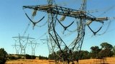
Dated coal and gas infrastructure to blame for Vic blackouts: Energy Minister
7:12

Driver of stolen vehicle arrested in Nerang after ramming police car
1:46

RAW: Cops make arrest after cops make heroin, ice bust
1:02
- 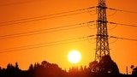
Random blackouts leave 300,000 Victorians powerless
3:58
- 
Hundreds of firefighters battle dozens of uncontrolled fires in Tas
5:01

RAW: Tas firefighters work to protect Huon Pine Walk
0:58
- 
RAW: Tahune fire 'creates own updraft'
0:08

RAW: Fire burns at Tasmania's Celtic River, air tractors fly over Celtic Hills
0:50

PM's morning tea at the Lodge for the 2019 Australian's of the Year
2:39
- 
Helicopter shot Tasmania fire burning in Central Plateau
0:07

BOM update: Extreme heat with cool change on the way
1:53

Victorian Energy Minister Lily D'Ambrosio says energy suppliers can meet demand
2:51

Melbourne mum asks politicians to search conscience after handing over pill testing petition
1:34
- 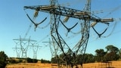
Blackouts to affect more than 100,000 Victorians at random
4:59

Daley accepts petition but remains unmoved on pill testing
2:53
- 
Senator Ernst reveals she was raped in college
2:27
- 
If Senate leaders reach deal, Trump says would back it
1:23
- 
Trump: Pelosi was 'reasonable' on SOTU
0:33
- 
Trump hails new Senate talks after shutdown bills fail
1:47
- 
Florida Governor Ron DeSantis says blackface controversy is 'unfortunate'
0:31

What happens when migrants break Australian law?0:52
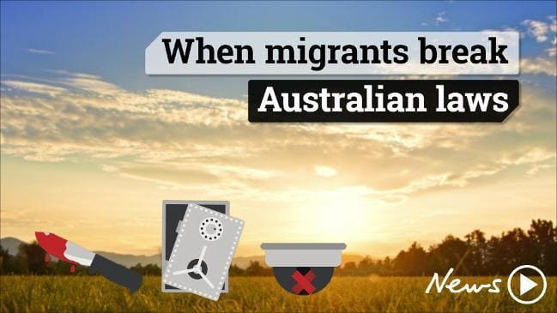
Any foreign national who comes to Australia must abide by Australian laws. So what happens when they don't?
- February 27th 2018
- a year ago
- /display/newscorpaustralia.com/Web/NewsNetwork/Network News/National/
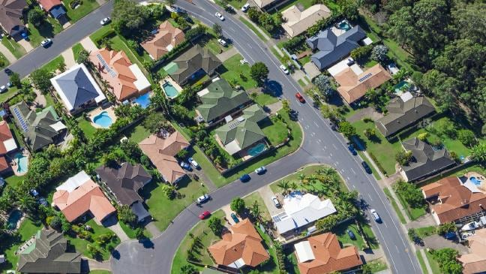
Areas have been enriched by immigrants.Source:istock
MY NEIGHBOURHOOD knows what happens when a large number of immigrants move in.
You just have to go 50m from my house to see the consequences.
Australia welcomed its 25 millionth resident on Tuesday, with overseas migration fuelling population growth (accounting for 62 per cent).
Reserve Bank governor Philip Lowe this week used the 25 million population milestone to laud the economic benefits of immigration.
It had produced a younger, more economically resilient nation, he told a business lunch in Sydney, adding migration “has helped our economy adjust to large swings in the demand for labour, and helped address some particular skills shortages.”
It came as the Federal government came under pressure to reduce immigration rates, with critics saying it permits population growth that puts pressure on housing and infrastructure.
Mr Lowe has probably has never been to where I live, but he would not be surprised by what has happened to it.
This is what Mr Lowe would find in our little shopping centre:
The pharmacy is run by a smart young woman of Asian extraction. I don’t know her specific heritage because it has never come up.
But I do know the two nearby GPs whose patients rely on her were born in Malaysia.
Next to the pharmacy is the newsagency, run by a family of Vietnamese Australians.
Across from them is a cafe, also run by Australians with a Vietnamese background, as is the next-door bakery.
At the end of the row is the barber, who ruins the symmetry by not being Vietnamese. He was born in Iran.
There used to be a fish and chip shop run by a woman with a heavy East European accent. Down from her was a restaurant run by Nepalese Australians.

Reserve Bank governor Philip Lowe. Picture: Hollie Adams/The AustralianSource:News Corp Australia
Unfortunately they were closed in a zoning dispute involving the landlord, a prominent Greek-Australian family.
Now the nearest eatery is a splendid Indian restaurant, just down the main road.
Philip Lowe would not only recognise this array of imported energy and ambition, he would applaud it.
While some hand-wringing commentators pump up alarm over our immigration rate and our 25 million population, Mr Lowe sees it as an economy-saving injection of freshness and youth.
In fact he has called immigration a “basis for optimism about the future of our economy”.
My neighbourhood commercial profile demonstrates how immigrants can pay their own way, and the 500,000 overseas students in Australia mean most immigrants on average are better educated than many born here.
undefined
Another important benefit is they make our population younger.
“The movement to Australia of large numbers of young people over the past decade has changed our demographic profile in a positive way,” Mr Lowe said.
“Of particular importance is the fact that, on average, new immigrants to Australia are younger than the resident population,” Mr Lowe said.
He said the median age of new immigrants is between 20 and 25, which is more than 10 years younger than the median age of the resident population.
Over the past five years, over 80 per cent of net overseas migration has been accounted for by people under the age of 35.
https://www.news.com.au/lifestyle/real-life/news-life/this-is-what-happens-when-immigrants-move-to-your-suburb/news-story/4153e8dda8ab704c5fd9d9b708bc9ea8

